NEWSLETTER HEADLINE
PROJECT NEWSLETTER MARCH 2017
News 1 / Headline
DANUBE PORTS NETWORK – BALANCED DEVELOPMENT OF DANUBE PORTS
News 1 / Photo

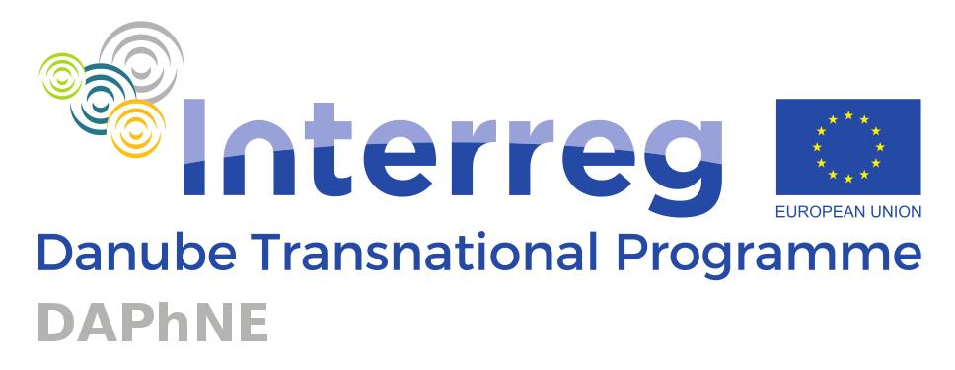
News 1 / Intro

On 1 January 2017, twenty-three partners from the Danube region officially started the project DAPhNE (Danube Ports Network). Co-funded by the Danube Transnational Programme as one of the 54 approved projects out of 547 initially submitted applications, the project focuses on improving the performance of Danube Ports with the aim to turn them into buzzing economic centres. In a nutshell, DAPhNE touches on topics such as port legislation & funding, port administration & management, port development and port strategy & port network formation.
By exploring these four topics, the consortium will significantly contribute to stepwise close the existing gaps between the 70 Danube ports located along the 2.414 km of the Danube River that deal with poor access infrastructure and superstructure, uncoordinated legal and regulatory frameworks, different ownership and administrative models, reduced private investments in the port area and decreasing human resources for this specific sector.
Thirty months of pioneering work are lying ahead of the DAPhNE consortium (January 2017-June 2019) under the coordination of Pro Danube International as lead partner.
The total budget of the project is 2.985.406,15 Euro, out of which the ERDF contribution amounts to 2.415.219,77 Euro & the IPA contribution amounts to 122.375,77 Euro.
Read more
Follow the DAPhNE project on social media:
- Facebook: https://www.facebook.com/INDanube/
- Twitter: https://twitter.com/INDanube
- LinkedIn: https://www.linkedin.com/groups/8560850
www.interreg-danube.eu/daphne

News 1 / Read more text

On 1 January 2017, twenty-three partners from the Danube region officially started the project DAPhNE (Danube Ports Network). Co-funded by the Danube Transnational Programme as one of the 54 approved projects out of 547 initially submitted applications, the project focuses on improving the performance of Danube Ports with the aim to turn them into buzzing economic centres. In a nutshell, DAPhNE touches on topics such as port legislation & funding, port administration & management, port development and port strategy & port network formation.
By exploring these four topics, the consortium will significantly contribute to stepwise close the existing gaps between the 70 Danube ports located along the 2.414 km of the Danube River that deal with poor access infrastructure and superstructure, uncoordinated legal and regulatory frameworks, different ownership and administrative models, reduced private investments in the port area and decreasing human resources for this specific sector.
For the Danube Ports to be able to provide a similar level of services and to use comparable technologies, an extensive know-how built-up and transfer in the region will take place. This will allow the less developed ports to benefit from the lessons learnt by their more advanced counterparts. Public and private entities active in the port sector will work together to facilitate the transition.
The collaboration will not only occur on a geographical level, but it will be inter-sectoral and transnational in nature. Port administrative processes and business strategies will be upgraded by introducing measures designed for greening ports. The use, provision and distribution of alternative energy will be analysed relying on the best practice examples already available. Furthermore, the needs and expectations of the port employees will be taken into account when revising the port business strategies.
Danube ports will earn their future status as highly advanced logistics centres only by providing their users high quality services and detailed live information on the shipments in progress. To do this there will need to be innovative IT solutions applied in the region like a Port IT Community System for the Danube ports similar to the ones already in use in some European maritime and inland ports. The DAPhNE partners will work on the model architecture of such a system and test it out as pilot actions.
To help the Danube ports reach their full potential in a balanced manner, the consortium will introduce a model state-aid scheme to facilitate private investments in the region. There will also be recommendations made for improving the legal framework, port processes and port management aspects. Relying on the examples in the Rhine region, a dedicated Green Port Policy for the Danube will be drafted, setting the basis for national programmes and other EU initiatives designed to upgrade the environmental performance of ports as multi-modal hubs.
By June 2019, the ports will have access to the Danube Port Development Strategy and its corresponding Action Plan explaining the steps to be made and the tools and instruments available to boost IWT and transform ports into buzzing economic centres.
Furthermore, the Danube Ports Network Platform will be set-up as a permanent communication channel between all port community members in the area. All interested parties will have access to this platform by electronic subscription and all DAPhNE outputs, deliverables and results will be shared with the members and associated partners.
Thirty months of pioneering work are lying ahead of the DAPhNE consortium (January 2017-June 2019) under the coordination of Pro Danube International as lead partner.
The total budget of the project is 2.985.406,15 Euro, out of which the ERDF contribution amounts to 2.415.219,77 Euro & the IPA contribution amounts to 122.375,77 Euro.
In case you want to learn more about the project, please contact Pro Danube International:
Raluca Danila (Project Manager): danila@prodanube.eu/ +43 1 890 66 47-23
Visit us at: www.interreg-danube.eu/daphne
Follow the DAPhNE project on social media:
- Facebook: https://www.facebook.com/INDanube/
- Twitter: https://twitter.com/INDanube
- LinkedIn: https://www.linkedin.com/groups/8560850

News 2 / Headline
SUCCESSFUL KICK-OFF MEETING IN BUDAPEST
News 2 / Photo
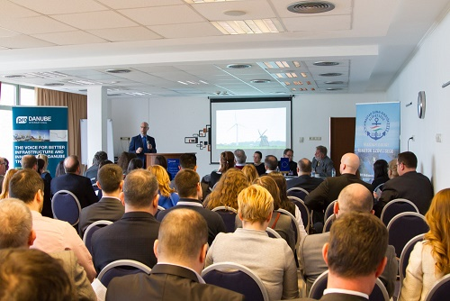
News 2 / Intro
On 20 February 2017, DAPhNE was officially started with a successful kick-off event in Budapest, hosted by the Hungarian Federation of Danube Ports. The event was designed to raise awareness of the objectives and activities of the project and provide information to the public and private stakeholders on the expected results and benefits. Over 70 stakeholders of the Danube Port Community attended the event to learn more about DAPhNE and to use the possibility of networking. The event brought together high level representatives from the European Federation of Inland Ports (Mr Alexander van den Bosch) and from the Hungarian Federation of Danube Ports (Mr Szalma Béla) as well as project Officer Mrs. Ana Leganel from the DTP Joint Secretariat.
Read more
News 2 / Read more text
Direct link to project news from 01/03/2017:
http://www.interreg-danube.eu/news-and-events/project-news/358
News 3 / Headline
WHO WE ARE – INTRODUCTION OF THE PARTNERSHIP
News 3 / Photo
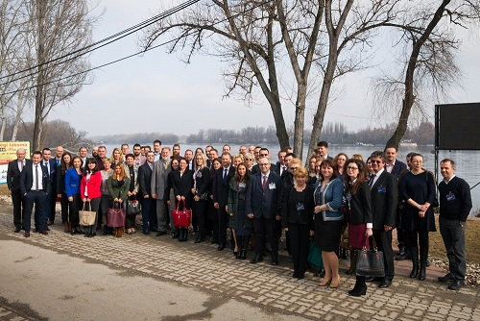
News 3 / Intro

The DAPhNE consortium consists of 23 partners from 9 Danube riparian countries (AT, SK, HU, HR, RS, RO, BG, MD, UK), committed to support the future development of the Danube ports. We all have ample expertise in IWT, port operations, legal & administrative frameworks, research & innovation, education & human resources.
Read more
News 3 / Read more text

Direct link to project news 28/03/2017:
http://www.interreg-danube.eu/news-and-events/project-news/446

News 4 / Headline
PROJECT PROGRESS IN THE FIRST 3 MONTHS
News 4 / Photo
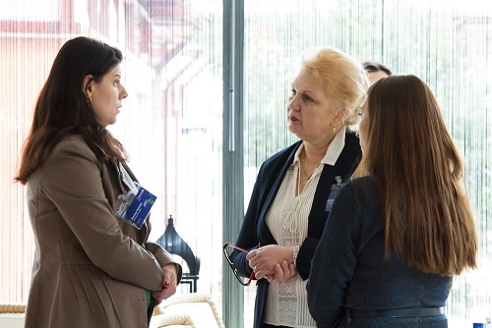
News 4 / Intro

In line with the approved application form, the DAPhNE partners started working on the planned tasks. The first consortium meeting and the first work package leader meeting took place in February where the partners discussed the work plan in detail and agreed in the next steps. Partners have started the preparatory activities of each work packages.
Read more

News 4 / Read more text

In line with the approved application form, the DAPhNE partners started working on the planned tasks as follows:
1. Project Management (Contact Person: Raluca Danila/PDI - danila@prodanube.eu)
A series of meetings were organized in order to clarify issues related to the distribution of tasks, internal deadlines and next steps for 2017. The 1st Consortium Meeting took place in Budapest/HU on 21st February 2017. There were 47 representatives of the project partners attending the event. The 1st work package leader (WPL) meeting was organized the same day in the afternoon. The topics discussed were related to a revision of the project calendar, next meeting date and templates to be elaborated.
Some of the DAPhNE partners (AT, HR, RO) also attended national events organized by the Managing Authority of the Danube Transnational Program (DTP) in order to clarify issues dealing with the validation of costs and the reporting rules applicable at programme level.

2. Communication Activities (Contact Person: Monika Thury/HFIP: popeiproject@gmail.com & Ruxandra Florescu/PDI: florescu@prodanube.eu)
In line with the visual identity guidelines, the partners have prepared the project template documents and have posted information online at: www.interreg-danube.eu/daphne. Promotional materials (posters, roll-ups, folders) have also been made to further inform about the project.
On 22 March 2017, the Bulgarian Partner BPICo presented the DAPhNE project as part of the Kick-off event of the DBS Gateway Region project funded in the framework of the Danube Transnational Programme. The event took place in Sofia/BG.
On 30 March 2017, Capt. Szalma Béla, president of HFIP introduced the DAPhNE project at “HajózásVilág” Conference to more than 80 stakeholders from the Hungarian Danube Port Community. The event was held in Budapest/HU.

3. Port Legislation & Funding (Contact Person: Luminita Meterna/APDM: marketing@apdmgalati.ro)
The project partners have started working on creating national databases for experts in the field of port legislation and public funding. For suggestions regarding relevant entities in the Danube region, please get in touch with the indicated contact person.

4. Administration & Management (Contact Person: Vasil Hadzhiev/BPICo: v.hadzhiev@bgports.bg)
The partners have started preparing a draft survey designed to collect information from port users in regard to the procedures applied by port authorities/administrations that have to be simplified. In parallel preparations are made to collect data regarding the status-quo of human resources development for the port sector in the Danube region.

5. Port Development (Contact Person: Karin Kainzinger/EHOO: k.kainzinger@ennshafen.at)
To help develop a Port IT Community System applicable to Danube Ports, the DAPhNE partners will rely on the experience of maritime ports from the Rhine Region. Consequently, a study visit to in Antwerp/BE is foreseen to get familiarized with the IT System applied in that area. The partners are making the necessary arrangements to prepare the study visit and collect the technical data needed.

6. Port Strategy & Network (Contact Person: Silviu Meterna/PDR: meterna@prodanube.ro)
The tasks carried out in this section are designed to set-up the Danube Ports Network and to elaborate the Danube Ports Development Strategy and its accompanying Action Plan. To help promote the network a series of events will be implemented at consortium level to facilitate networking possibilities within the port community and also to help consolidate the market visibility of its members. The partners are working on the organization of two high awareness events, namely the Danube Ports Info Day scheduled for May 2017 in Munich/DE and the Danube Ports Policy Day planned for October 2017 in Budapest/HU.
Direct link to project news 31/03/2017:
http://www.interreg-danube.eu/news-and-events/project-news/453

News 5 / Headline
UPCOMING EVENTS – SAVE THE DATE!
News 5 / Photo
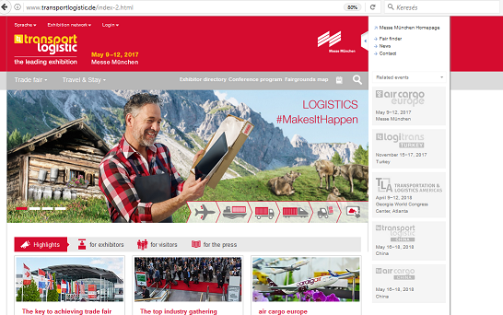
News 5 / Intro

To help tighten the ties between the Danube Port Community members, a series of events have been planned by the DAPhNE partners. Interested parties are invited to attend and get in contact with the Lead Partner - PDI to learn more about the conditions for participation (Raluca Danila – Project Manager/PDI: danila@prodanube.eu )
Read more

News 5 / Read more text

To help tighten the ties between the Danube Port Community members, a series of events have been planned by the DAPhNE partners.
Interested parties are invited to attend and get in contact with the Lead Partner-PDI to learn more about the conditions for participation (Raluca Danila – Project Manager/PDI: danila@prodanube.eu )

Danube Ports Info Day
Munich/DE, 11th May 2017, 12:00 - 14:00, Transport Logistic Fair Munich/DE, Hall B3/ 306
The Danube Ports Info Day is meant to promote Danube Ports as logistics & service hubs as well as ideal locations to setting up businesses needing waterborne & intermodal logistics infrastructure. The Danube Ports Info Day shall facilitate a structured discussion on port development opportunities touching on topics such as port infrastructure, PPPs for port investments and innovation& new markets in the Danube Region. This shall enable Danube Ports to transform more effectively into centres for regional development. The dialogue between industry representatives and port authorities will identify requirements for cost-effective logistics solutions and shortcomings as well as special investment / co-operation opportunities.

Read more: http://www.transportlogistic.de/index-2.html

Danube Ports Policy Day – Budapest/ HU, 18/19 October 2017, 6th Annual EUSDR Forum
The event will be connected to the programme of the 6th Annual EUSDR Forum. It will address port policy & port governance issues for all Danube Ports. The participation of DG Move & DG Regio representatives is foreseen in order to learn first-hand about the ongoing and forthcoming EU port legislation, EU funding and finance opportunities for port development and modernization.
Read more: https://www.danube-region.eu/communication/events/600198-6th-annual-forum-of-the-eusdr/event_details

Direct link to project news 31/03/2017:
http://www.interreg-danube.eu/news-and-events/project-news/454

